**Batch :D2 Roll No.: 16010221038**

**Experiment / assignment / tutorial No. 6**

**Grade: AA / AB / BB / BC / CC / CD /DD**

**Signature of the Staff In-charge with date**

**TITLE:** Array of Structures.

**AIM:** Program to declare an array of structure `players` having data members (name, total matches played, best bowling figure). Program should do the following operations using functions.

1. **Insert Minimum 5 player data in array of structure**
2. **Sort and display this data in descending order of their best bowling figure (if wickets are same then consider less run conceded as priority) and in proper tabular form**
3. **Delete the data for any one player.**
4. **Search for a particular player using its name.**

**Expected OUTCOME of Experiment:**

**To print the expected array**

**Books/ Journals/ Websites referred:**

* 1. Programming in C, second edition, Pradeep Dey and Manas Ghosh, Oxford University Press.
  2. Programming in ANSI C, fifth edition, E Balagurusamy, Tata McGraw Hill.
  3. Introduction to programming and problem solving , G. Michael Schneider ,Wiley India edition.
  4. [**http://cse.iitkgp.ac.in/~rkumar/pds-vlab/**](http://cse.iitkgp.ac.in/~rkumar/pds-vlab/)

**Problem Definition:**

Create an array of structure ‘players’ which store information about multiple players having different data members such as name, total matches played, best bowling figure. Program should read choice from the user and perform following function:

Choice 1: Insert data in array of structure.

Choice 2: Sort and Display

Choice 3: Delete a player

Choice 4: Traverse and search a player with given name.

**Algorithm:**

Step 1: Start.

Step 2: Define structure.

Step 3: Use switch case for insert, sort, delete, search and end.

Step 4: Accept user input (choice).

Step 5: Repeat Step 3 and 4 till choice exceeds the number 5.

Step 5: Case1 - Insert and store number of players, player name, matches played and bowling figure.

Step 6: Case 2 - Sort by comparing bowling figure and display sorted data.

Step 7: Case 3 - Input name of player for which entry has to be deleted and display array structure after deleting.

Step 8: Case 4 - Input player name for which player statistics have to be searched and display statistics for that player.

Step 9: Case 5 - Go to step 11.

Step 10: If choice is not equal to 1,2,3,4 or 5, print “Invalid Choice”. Step 11: Stop.

**Implementation details:**

#include<stdio.h> #include<conio.h>

struct players { int mplay,bowfig; char name[25]; }player[5],t;

int i,j,n;

void main() {

int ch; while(ch!=5)

{ printf("\n1.Insert data in array structure. \n2.Sort and Display. \n3.Delete a player.

\n4.Traverse and Search a player with given name.\n5. End \n\n"); printf(" Enter your choice ");

scanf("%d",&ch); switch(ch)

{

case 1: insert(); break; case 2: sort(); break; case 3: delete(); break; case 4: search(); break; case 5: break;

default: printf("Invalid choice");

}

} getch();

}

void insert() //function to insert data

{

printf("Insert data for how many cricket players\n");

scanf("%d",&n);

printf("\n Enter player name , matches played and bowling figure\n"); for(i=0;i<n;i++) {

scanf("%s %d %d",player[i].name,&player[i].mplay,&player[i].bowfig);

} }

void sort() { for(i=0;i<n;i++) { for(j=0;j<n-1;j++) { if(player[j].bowfig<player[j+1].bowfig) { t=player[j]; player[j]=player[j+1]; player[j+1]=t;

} }

}

display(); }

void display() //function to display data {

printf("\nCricketer info in terms of matches played and bowling figure \n");

printf("\nName\t\tMatches played\t\t\tBowling figure\n"); printf("--------------------------

\n");

for(i=0;i<n;i++) {

printf("%s\t\t\t%d\t\t\t%d\n",player[i].name,player[i].mplay,player[i].bowfig); }

}

void delete() { int x;

char n1[25];

printf("Enter player name which you want to delete \n"); scanf("%s",n1); printf("\nDisplaying after deletion\n"); for(i=0; i<n; i++)

{

if(strcmp(n1,player[i].name)!=0) printf("%s\t\t\t%d\t\t\t%d\n",player[i].name,player[i].mplay,player[i].bowfig);

}

n=n-1; }

void search() {

char n1[25]; printf("Enter player name which you want to search \n"); scanf("%s",n1); printf("\n name to be searched %s\t ",n1);

printf("\nDisplaying after search\n"); for(i=0; i<n; i++) {

if(strcmp(n1,player[i].name)==0) printf("%s\t\t\t%d\t\t\t%d\n",player[i].name,player[i].mplay,player[i].bowfig);

} }

**Output(s):**

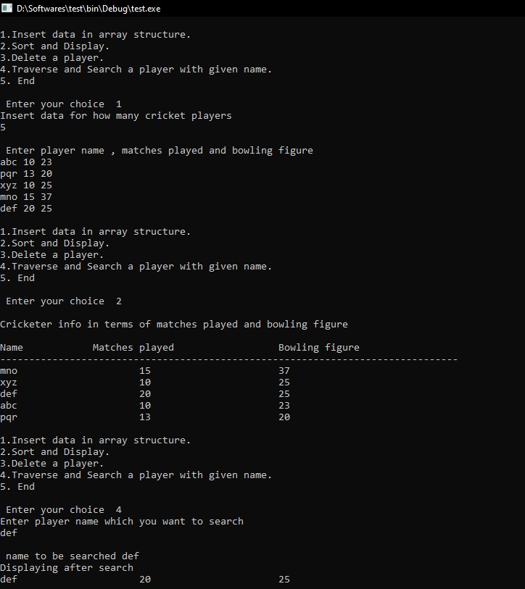

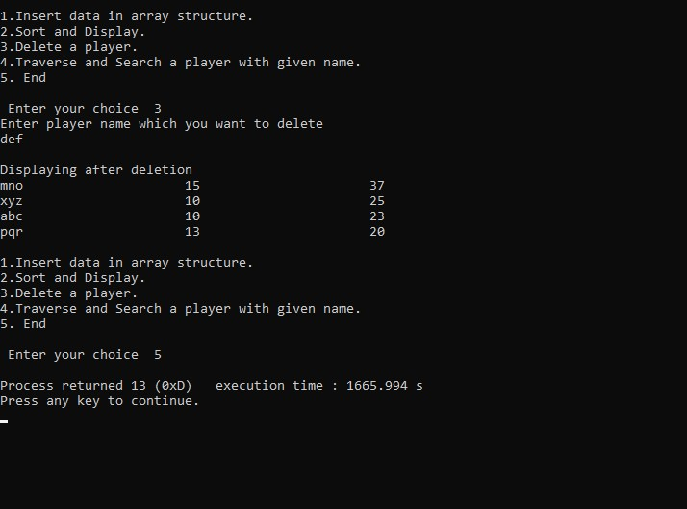

**Conclusion:**

As per user input, data was entered, sorted, searched and deleted from the array.

**Post Lab Descriptive Questions**

**1. Comment on the output of the following C code.**

#include <stdio.h> struct temp

{ int a; int b; int c;

}; main()

{ struct temp p[] = {{1, 2, 3}, {4, 5, 6}, {7, 8, 9}}; }

**ANS:NO OUTPUT**

**2. Consider the following C code. What will be the output?**

#include<stdio.h> struct st

{ int x; struct st next;

};

int main()

{ struct st temp; temp.x = 10; temp.next = temp; printf("%d", temp.next.x);

return 0;

}

1. Compiler Error
2. 10

1. Runtime Error
2. Garbage Value

**Answer:** (A) Compiler Error.

**3. Difference between Structure and Union.**

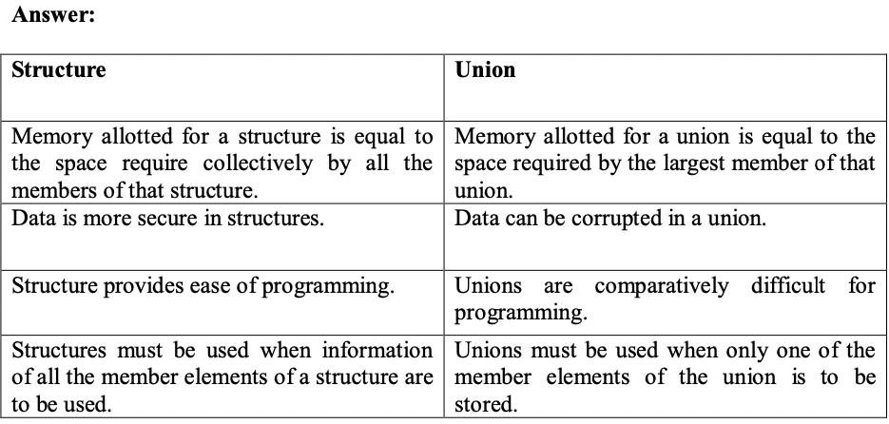

**Date: Signature of faculty in-charge**